

It unit 28.1

By Adam Chu



Contents

Web architecture 3

Internet 3

Intranet 3

Networks 3

Wan 3

PAN 4

MAN 4

LAN 4

Wired and Wireless connections 4

Dial up 4

Wireless 4

Ethernet 5

ADSL 5

Fibre Optic 6

Topologies 6

Bus 6

Note 6

Ring 6

Star 6

Peer to Peer 7

Client-Server 7

Hardware and Components 7

Routers 7

Switches 7

Hubs 7

Cables 7

Co-axial 8

Modems 8

Devices 8

Games Consoles 8

Mobile Phones 8

PC 8

TV 9

ISPs 9

Software 10

Web Hosting 10

Domain Structure 10

URL 10

URN 10

Top level 10

Sub-Level Domains 11

Domain name 11

Humanly rememberable name 11

IP address 11

IPv4 11

IPv6 11

Port Numbers 11

SSL - Secure Socket Layers 11

World Wide Web 11

Explain the role of web architecture in website communication 12

Components 12

Packets 12

Packet Switching 12

Search engine optimisation 12

Meta-tagging 12

Static Websites vs Dynamic Websites 12

Blogs 12

Social Networking 13

Cloud Computing 13

Dynamic Scripting Language 13

JavaScript / Ajax 14

Explain the role of the TCP / IP protocol and how it links to application layer protocol 14

Protocols / layers 14

Transport and addressing 14

TCP/IP Has 4 layers 14

Application layer 14

Transport layer 14

The Network Layer 14

The Physical Layer 14

HTTPS 15

SMTP 15

# Web architecture

## Internet

The internet is a collection of webpages linked together by the World Wide Web this is on an international scale, this can be accessed by smaller houses or larger business the internet is collection of data, these interlinked pages are also linked with servers’ large computers that are designed to be accessed remotely streaming data there is a type of attack called DDOS where the user sends massive amounts of data in large quantities to a server which means the server has to stop sending traffic to legit and actual users to disconnect.

# Intranet

The intranet is the private network each house or estate has these can include many different LAN’s over a leased WAN lines. These intranets have one or more gateways to the outside world this is because they are designed for a household meaning more than one device is connected to the internet at a time so they need a moderate amount of gateways.

# Networks

Networks are connected computers that can share resources (this can be hardware or software) these are affected in the way the computers are connected this is also impacted by the data flow between each computer.

An example of hardware resource is a printer

An example of a data resource is this report which I am transferring to and from the server.

## Wan

This WAN (wide area network) is the network that interconnects LANs to a larger network this is usually made up of LANs that are interconnected this is also what the internet runs on they also cover a large geological area.

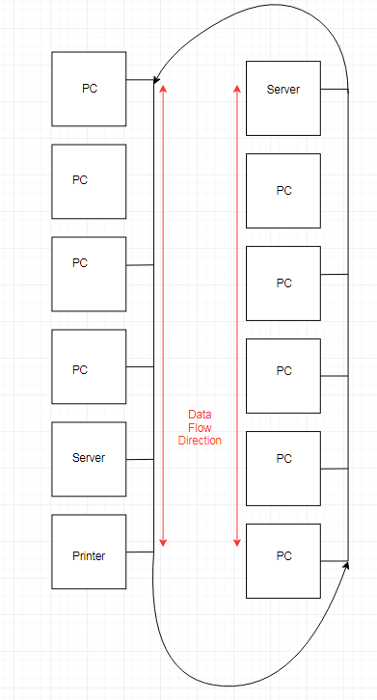This is a Wan as it links two bus LAN networks you do not need to links for bus as in the Bus network data travels in both directions.

Wan takes many LAN networks and interconnects those the problem is that the wan is directly affected by the type of connection which I will cover later. And the LAN network design affect the type of WAN and the speeds it can achieve.

### PAN

Personal area network (PAN) is where the computer is sending data between itself and the WAN (internet) this is where one master ‘device’ is taking up the role as gateway this is mainly seen when the computer uses infrared transmission and the Bluetooth system which use PANs to share data. `

### MAN

Metropolitan area network is the network that connects the computers (devices) with a network which is smaller than a WAN but larger than a LAN. This is in actuality is that the LANs within the city or urban area are connected together which can offer a fast connection to the WAN

### LAN

LAN (local area network) is where the computers are interconnected this can be explained by the topologies below these topologies these LANs are mainly used in households and businesses. Wired LANs are more secure and are not prone to data leaking to the internet as well as faster which is why businesses usually use L. Wireless Lan is slower, but the main gain is that the computers can be anywhere on building as long as there is a router nearby.

## Wired and Wireless connections

This technology uses three items the NIC (network interface card) and the router as well as the modem, the modem decodes and codes the data that is sent in and out of the LAN or WAN. The NIC will allow the data to leave the device and go the modem which will compress it, the NIC also has the MAC address which is what tells the router which computer to send the data.

### Dial up

Dial Up is a form of internet access that used the telephone network (at the time) this is called the ‘public switched telephone network’ (PSTN) this used the telephone network to dial a number to the ‘internet network provider’ (ISP). The dial up has a modem attached to it which decodes the audio signals which are transmitted through the phone line. This had a download speed of 56 KPS (Kilobytes per second) this was only effective for web 1.0 as the small download speed it also wasn’t enough to have the phone line running.

### Wireless

The main flaw with wireless is that the connection has limited range as the radio waves are partially blocked by the air or the walls of the living estate. The speeds are limited by the model of modem and router. But even if the maximum speeds are high being further away makes the connection drop. Modern Wi-Fi can have high speeds mine is 80MBS (Megabytes per second) download speeds and has 20MBS upload speed, this is considered fast for a normal house.

Also Wi-Fi requires a special type of NIC (network interface card) which has its own bandwidth limitations most devices use a PCI - Express generation 3 mini PCI-E (Mini is the form factor) card made by Intel these have multiple hundreds of MBS it shows the maximum speeds on this car it is 867MBS this card is the Wireless-AC 8265. The other image is a riser that takes mini PCI-E and takes it to PCI 1x (smallest desktop size)

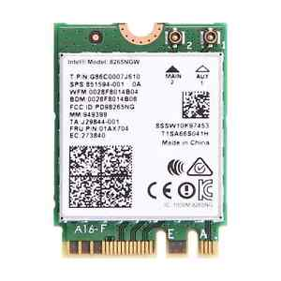 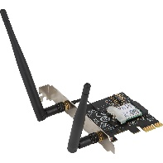

### Image result for 10gb ethernet motherboardEthernet

An Ethernet cable is another connection to the internet using a wire this is faster than the wireless method has less latency as well as there is no degradation due to displacement from the modem or router. Most motherboards feature a wired NIC so that there is no extra cost.

The pros against co-axial is that the signal is stronger than it used to be, as well as the distortion due to EM interference is less as there is less indirect cabling and its cheaper.

Also Cat 6 (category 6) can reach approximately 50 metres without the signal being unusable due to the distortion.

The distortion is protected via the shielded type of RJ45 which is solid and used in businesses where the cables are sealed within the walls and are not intended to be moved.

The other type is a stranded type which are more flexible and are used by the home which is cheaper as well.

This is the Asus X99-E 10G WS a motherboard from 2016 which at MSRP ‘£400’ Approximately this motherboard supported 10GB Ethernet through Cat 6. Now in 2018 its price ‘£440-£500’ this motherboard is an ultra-high end this is from the same year as the high-end wireless card 10GB is a lot higher than 867 MB.

### ADSL

This is the 2 line dial up connection as before both the telephone and wireless network both used the same line this has been improved by the ISPs and telephone companies by having two separate lines, this is the most commonly sent to homes as there download will usually higher than the upload so the ADSL (Asymmetrical Digital Subscriber Line)

ADSL means that the Upload and Download bandwidth are not the same as in Asymmetrical

### Fibre Optic

The fibre optic standard is where the data is coded and transferred through light as a medium meaning theoretically the transfer speed is the same as the speed of light in a vacuum. They are passed through optical fibres which are a non-metallic cylinder made of a material. This is lighter and immune to EM radiation (does not release), EMPs, Not possible to light a fire, corrosion resistant. This is the better way to transmit data as it is light sent in bursts which are decoded at either end and is coming down in price.

# Topologies

## Bus

I have made a simple BUS network above the arrows are where the individual network are connected.

Bus is where there is one main cable that splits for every connected device the main advantage of bus is that it’s relatively cheap and is the easiest to set up as there isn’t directional cable.

A disadvantage of BUS is that there isn’t a switch involved meaning that the data is sent to all of the computers meaning a high level of trust is needed, also the bus network relies on one cable for all data transfer meaning that the computers have a small and limited bandwidth.

### Note

Most modern PC’s support 1GB bandwidth through CAT 6 but that depends on the NIC on extremely high-end PC’s the Cat 6 can use 10GB bandwidth. Meaning bus will be improved in these circumstances but the gains would be more noticeable using star topology.

## Ring

This is a modified version of bus in which the data can only flow in one direction this means the bandwidth issue in which if data flows in both directions it can stop the data flow completely, is non-existent. But there is a new issue in that the data has to send it to every computer meaning there can be a time delay depending on the computer the data is intended to go to. Again this is cheap as there is no hub or switch required for it. I.e. sending a word document from PC 1 to the server it has to send the data to every computer on the network first.

## Star

This is the star topology which is considered the most efficient but the most expensive. This uses a switch or hub to send the data to the right computer.

The reason why a switch is considered better than a hub for this is the way the data is sent out a switch will send the data to the right computers whereas a hub will send it to all of the computers in the star network.

## Peer to Peer

A peer to peer network is where two computers are linked together to share resources with neither having a dedicated server, this is can be any form of interconnected devices this can be formed when you connect your PC to the phone through Bluetooth or USB (ALL if data is being transferred)

## Client-Server

Client - server networks are where the computer ‘asks’ the server to send them data this is designed for ADSL as the computer doesn’t send much data to the server it mainly receives. This is how the internet works.

# Hardware and Components

## Routers

Routers are the part of the way data is sent to and from the internet what it does is it send the data packets between networks it also is used to send IP packets from your computer to the internet this is used in DSL routers which connects to the ISP with the IP packets which the ISP uses to connect you to the right webpage and server.

## Switches

The switch is a device that checks the MAC address and IP address of the device this is to send the data packets to the right location this is useful for star, the problem with a switch is that it requires a new RJ45 Ethernet cable as each lane is separate.

## Hubs

A hub is like an inferior version of a switch as instead of selecting where the data will go it sends it to everyone on the network this has the problem of the fact it’s relatively expensive due to the fact you need a large amount of cables and the hub can be expensive.

## Cables

I have covered Ethernet (RJ45) and fibre optic in earlier part of this report

### Co-axial

Or RG-60/U is the Co-axial cable that is used for the internet access. The coaxial cable is designed around the principle of how do we create a cable that is protected from electromagnetic interference. But this benefit is negligible as Ethernet is so advanced that the EM protection is not a big of an issue as it used to be.

The design is that the metal core which is covered in a dielectric insulator which is then wrapped in a copper mesh which is covered in a rubber sleeve. This is similar to a faraday cage as it blocks and excludes the EM interference by insulating the EM fields to inside the cable.

Co-axial cables are used for longer distances where fibre optic would be applicable, but the budget or distance is not great enough to warrant fibre optic.

### Modems

Modems decode and code data and send it to the ISP this uses the telephone line what they do not do is chose which data packets go to which computer. This is because the router and the ISP use different languages (signal types) so they can’t technically communicate.

# Devices

## Games Consoles

Games consoles rely on the internet as they need the internet to update the OS as well as the social aspect of gaming that has increased in popularity. I have talked about the mini- PCI-E Wi-Fi adapters which most console use or make their own. The Consoles also usually has an Ethernet connector for faster and more stable gameplay with less latency.

## Mobile Phones

Mobile Phones usually have multiple ways to connect to the internet one of the more common ones is the Wi-Fi connectivity which uses the homes LAN (intranet) to connect to the internet, the other main type of connection is mobile data a PAN which allows internet access by using itself as the gateway to the WAN this uses the mobile carriers network as its modem and router.

## PC

PC support Wi-Fi and Ethernet based on what NIC’s you have installed most Intel motherboards support Ethernet through the Intel NIC built in. The things that can be installed on most ITX motherboards are Wi-Fi cards. This is also true for some non- small form factor (ATX m-ATX) high end motherboards as well. (X370 Taichi has this slot as well)

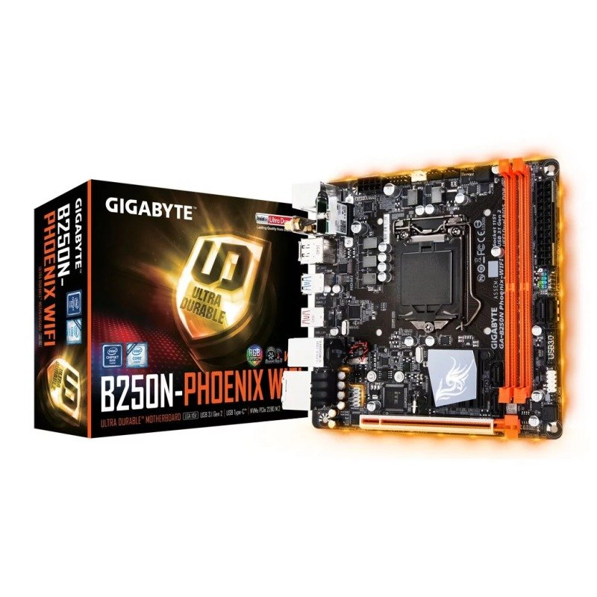

## TV

Some smart TV have Wi-Fi and Ethernet capabilities so that the user can use them without a set top box or a smart TV converter like the amazon fire stick. This is used on newer TV’s to allow them to access Hulu and Netflix as well as other streaming sites.

40” sharp TV

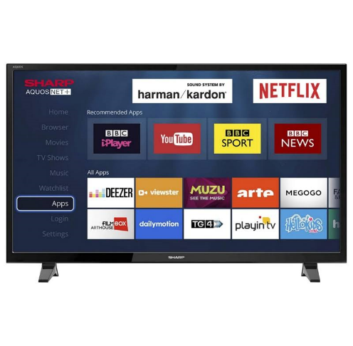

# ISPs

These are the Internet Service Providers who act as the middle men from the house to the internet. What they do it they decode the data sent from the modem outbound. They also take this outbound signal and send the packets to the server of choice.

The modem uses the telephone line to ring the ISP usually on a modern internet, the normal 2 line ADSL it can run the internet through the ISP as well as keeping the phone line open.

BT (British telecommunication) is the largest and most commonly used ISP in the UK. This ISP usually offers ADSL as this is the one usually offers to normal households due to people not uploading a lot of data.

Sky also offers ADSL internet as they offer similar packages that BT offer this is dependent on the area you live at, the ISP for Portland and Weymouth is BT.

My Internet is 70Mbs down, 20Mbs up.

# Software

### Chrome

Chrome is a web browser which allows the user to load the internet with a GUI as well as a set of automated features for chrome the user has on screen macros for back forwards reload & home, as well as the URL bar which also runs the string through the google spider.

### Email

Email servers use either the POP3 or IMAP system, the emails are an internet enabled system which allows the code to do one of two things based on the protocol used.

IMAP (Internet Message Access Protocol) is a protocol which allows the user to view a local version of the email if they can connect to the server via the internet. This is the one mainly used by the email systems like GMAIL as the user can still have access to the mails that are loaded in RAM.

POP3 (Post Office Protocol) is a protocol which downloads the mail to a local hard drive from the server and deletes it from the server meaning that the emails on the machine can be accessed without an internet connection as long as you have pre-downloaded them.

# Web Hosting

GoDaddy is a web hosting service which will take a HTML webpage and allow you to rent a space on their server which is then allowed access on the WAN (internet). GoDaddy also is the world’s biggest domain name registrar. GoDaddy charges £1 per month.

A DNS is the list of names that the internet uses the computer needs to access its DNS (Domain Name System) to ‘look up’ the IP address of the server you are trying to connect to. The GoDaddy system allows you to assign a new domain name to the IP you will use.

BlueHost is another company that offers a simple DNS hosting and registrar but instead of any HTML website, they state that their cost is revolved around the WordPress website builder at a cheaper cost. The cost is $2.95 a month.

# Domain Structure

## URL

Uniform Resource Locator is the name of the website or item, it also shows its location on the network and the way to obtain it. The URL mainly shown by http (web pages), but they also uses emails and databases. HTTP webpages (all) use (HyperText Transfer Protocol)

## URN

Uniform resource name is a resource (internet) that has a permanent space in the internet but any links to an URN will be un-useable if the URN has moved. URNs are used to make a site that probably will not change in its naming scheme.

## Top level

Top level URLs have the extension at .co.uk or .com what these do is they make the website seem more professional and a lot better to more consumers.

## Sub-Level Domains

Sub-Level Domains are the .org which are extensions that are less professional they are cheaper but seen as less used and less useable on a larger scale of business.

# Domain name

## Humanly remember able name

This means the name that you can remember as the casual user does not remember the IP of a particular brand they remember the logo or name of it.

It can be akin to the lack of remember phone numbers because you can assign it a name or a picture.

## IP address

The IP address is the name of the server you are trying to connect to. IPv4 is a set of numbers which tell the computer a lot of information about the server you are trying to connect to. There is 2^32 IP addresses. These IP 4 bytes of 8 bits, which are distributed by the router in the house these can change unlike MAC addresses.

## IPv4

The IPv4 is a 32-bit address which uses a decimal system to write in 8 bits, these are then collected in groups of 4. The IP addresses are used for households and businesses but because how interconnected the internet is they are running out of spare IPv4 addresses.

## IPv6

IPv6 the newer standard of IP addresses is designed to have 2^128 addresses which can fill the rest of the required IP addresses for the near future. But IPv6 cannot operate with IPv4 which means the transition phase is more complicated but there are functions that allow for some communication.

It has 4 hexadecimal * 8 groups with colons in-between.

## Port Numbers

A port is the code which tells the server which process the message is to be ‘forwarded’ this tells the server which also tells the server which application is being run or hosted for instance to host a Minecraft server you would use the port 25565.

## SSL - Secure Socket Layers

SSL is the security layer that the internet uses this is the way of encryption that the internet uses this to make sure the data you send and receive is not shown to other people.

# World Wide Web

The World Wide Web is a collection of URLs these contain every page and URN that the internet encompasses. The WWW is designed to allow transfer of HyperText Transfer Protocol. The Internet is the connection of many interconnected devices, whereas the WWW takes every item on the internet

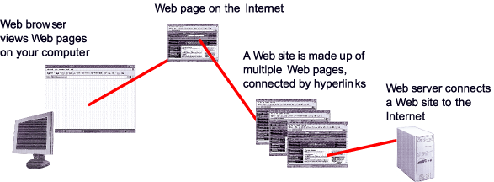

# Explain the role of web architecture in website communication

## Components

### Packets

Packets are where the data sent outbound what these mean is that the data does not have to be sent through one route. The packets have a payload and a header the payload will be sent across the WANs to get to the server. When they get there they are re-packaged.

### Packet Switching

Packet Switching is where the packets respond where the network fails and travel independently. Meaning that there is no wasted bandwidth.

## Search engine optimisation

### Meta-tagging

Metadata is the information about the data being sent you can assign tags which are the keywords used, the spider search engines look for new pages by looking at the tags. What you search in to the box looks for tags and words in the webpage before they are shown to you.

## Static Websites vs Dynamic Websites

### Blogs

Blogs are websites where the user updates the site with new articles, which the title will have usually an RSS feed. In Web 1.0 there would be a series of links which leads to a set of static articles. Most web 2.0 blogs would have creative and better animations as well as gifs, and images which make the page seen nicer to look at.

Wikis

The wikis are a series of interconnected pages which are mainly Web 1.0 as they have blocks of text surrounded in pictures and themes. Some Wikis use tables to keep the information separate. These Wiki’s like Wikipedia add pictures surrounded in captions.

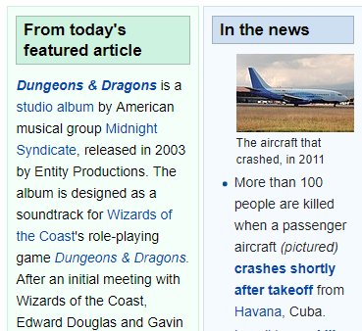

### Social Networking

Social Networking uses a Web 2.0 design as the main aspect of it changes due to posts and that the system uses dynamic image and design to constantly update as it uses a feed which subscribes and updates itself to what you have subscribed.

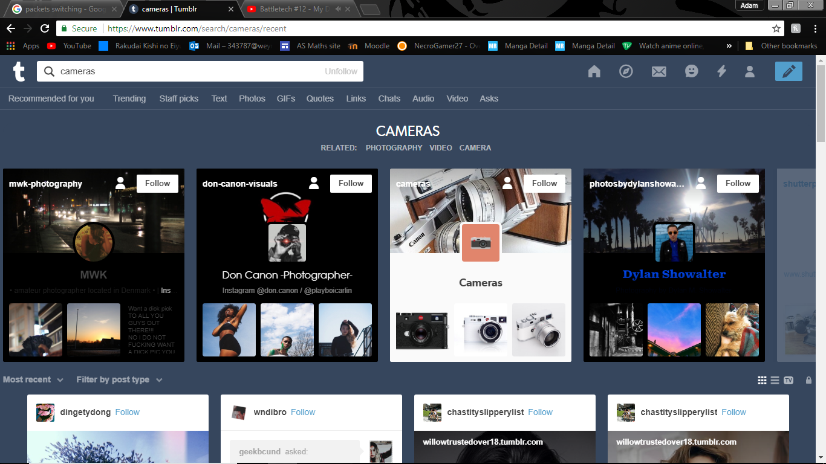

This is the part where you can subscribe to the feeds.

## Cloud Computing

Cloud Computing is a form of computing where the medium of transfer is the internet, Google Drive is a well-known company that offers Cloud Computing. Cloud Computing for the Google Drive ecosystem is where the user does not have to have the files saved locally they save it on their internet enabled server farm which then can be accessed anywhere if you are connected to the internet.

## Dynamic Scripting Language

The Dynamic Scripting Language which I will call DSL and this is a high level code which automatically updates when the code is being run. This could be adding new code, changing existing code & and updating variables.

## JavaScript / Ajax

JavaScript is the way to program the behaviour with webpages, it is a Client-side Scripting language which runs inside the internet browser. The JavaScript is run whenever you load a webpage, it can also be used to validate entries into a survey.

Ajax or Asynchronous JavaScript and XML allows the computer to send data to and from the server not at set intervals meaning that the data can be sourced in the background as well as the computer still show the current state of the webpage and the behaviour it would exhibit.

# Explain the role of the TCP / IP protocol and how it links to application layer protocol

## Protocols / layers

### Transport and addressing

TCP/IP is the set of rules that anything that is sent across the internet needs to, TCP/IP also needs to state which port and IP address that is being sent to and from.

## TCP/IP Has 4 layers

### Application layer

This is the layer which provides applications uniform data in exchange it uses the protocols HTTP (HyperText Transfer Protocol), FTP (File Transfer Protocol), POP3 (Post Office Protocol) and SMTP (Simple Mail Transfer Protocol). These protocols are designed to make sure the data is in the same format for each computer in the system.

### Transport layer

The transport layer handles maintaining the link between the network and the data flowing across it. The transport layer handles the TCP communication, and these includes the user datagram protocol UDP and which can be used instead of TCP communication.

### The Network Layer

The network layer also known as the internet layer deals the networks and the packets that travel between them. The network layer protocols use the IP protocols and the Internet Control Message Protocol (ICMP), which is an error reporting protocol.

### The Physical Layer

This is the layer which is made up of protocols which can only operate on a link, this layer is the part of the TCP/IP layers which has to control the nodes (parts inside a network). The protocols for this layer include Ethernet and the Address Resolution Protocol (ARP).

ARP is the protocol which assigns and secures the IP address the computer will user. IPv4 uses a 32-bit long series of binary which shows the IP address.

## HTTPS

Is an addition to HTTP which includes SSL and encrypts this, using a HTTPS link shows the user that the data is being protected. When you are paying for something online or signing in to a system remotely you want to have the HTTPS certificate.

It stands for HyperText Transfer Protocol Secure.

## SMTP

SMTP (Simple Mail Transfer Protocol) is a type of electronic mail, SMTP is used when the email is sent from the client i.e. GMAIL’s client to the GMAIL server it will use SMTP to send it from one computer to the server over port 26. It also does the same if the user has sent an email from one email server to another i.e. GMAIL to outlook.

Application Layer

TCP/IP Layer

Network Layer

Physical layer

Transport Layer